Wholesale Trading & Business Accounts Analysis
Using Microsoft Power BI
Project Report
Submitted By
Name: SHERENE.S
Tool Used: Microsoft Power BI Desktop

Introduction
The Wholesale Trading & Business Accounts Analysis Dashboard has been developed using Microsoft Power BI to analyze key business operations, including sales performance, profitability, customer receivables, collections, returns, and branch performance. The dashboard transforms raw transactional data into meaningful visual insights through interactive reports, KPIs, charts, slicers, drill-through pages, and tooltips.
The report is organized into five sections: Executive Sales Overview, Product & Discount Analysis, Customer & Receivables, Collections & Returns, and Branch & Salesperson Performance. These analyses help identify trends, monitor business performance, improve decision-making, and support effective management of sales and receivables.
Objectives
- To analyse overall sales and profitability performance through key performance indicators (KPIs).
- To evaluate product-wise sales, discounts, and profit contribution.
- To identify top customers and monitor outstanding receivables using ageing analysis.
- To assess collection efficiency and understand customer payment behaviour.
- To analyse product return trends and identify major return reasons.
- To evaluate branch, region, and salesperson performance across different geographic locations.
- To provide interactive insights using slicers, drill-down hierarchies, tooltips, and drill-through reports for detailed business analysis.
Dataset Description
The dataset used for this project represents the operations of a wholesale trading business accounts analysis and consists of both fact tables and dimension tables designed using a star schema model. The data covers the period from 1 July 2024 to 30 June 2025 and contains fictional records created for analytical and educational purposes.
The Fact Tables store transactional data:
- Fact Invoices – Contains invoice details such as invoice date, due date, customer, branch, salesperson, payment status, and invoice amount.
- Fact Invoice Lines – Contains product-level sales information, including quantity sold, selling price, discounts, net sales, cost of goods sold, and gross profit.
- Fact Payments – Records customer payment transactions, payment dates, payment methods, and payment amounts.
- Fact Sales Returns – Stores product return information, including return quantity, return reason, and return amount.
The Dimension Tables provide descriptive information for analysis:
- Dim Date – Date-related information such as year, quarter, month, and weekday.
- Dim Customer – Customer details and customer classifications.
- Dim Product – Product, category, and subcategory information.
- Dim Salesperson – Salesperson details and performance attributes.
- Dim Branch – Branch information.
- Dim City, Dim State, and Dim Region – Geographical dimensions used for location-based analysis.
The dataset enables comprehensive analysis of sales performance, profitability, customer receivables, collections, returns, product performance, branch operations, and salesperson effectiveness through interactive Power BI reports and dashboards.
Data Preparation
Data preparation was carried out in Power Query to ensure data accuracy, consistency, and compatibility with the Power BI data model. The process included cleaning, transforming, and validating the data before analysis.
The following data preparation activities were performed:
- Imported all fact and dimension tables into Power BI.
- Removed unnecessary rows and checked for missing or invalid values.
- Assigned appropriate data types to all columns, including text, whole numbers, decimals, and dates.
- Converted date key fields into date format where required for reporting and analysis.
- Created relationships between fact and dimension tables using a star schema model.
- Developed calculated columns and DAX measures for KPIs such as Total Sales, Gross Profit, Collections, Outstanding Receivables, and Receivables Ageing.
- Created drill-down hierarchies for geographical and product-level analysis.
- Validated data consistency to ensure accurate reporting and visualization.
These data preparation steps established a reliable foundation for creating interactive dashboards and performing meaningful business analysis.

DAX Measures Used
Several DAX measures were created to calculate key business metrics and support interactive analysis within the dashboard. These measures helped evaluate sales performance, profitability, collections, receivables, and returns.
- Total Sales- Calculates total net sales revenue.
- Gross Sales- Calculates total sales before discounts.
- Total Discount- Measures the total discount provided to customers.
- Total Cost of Goods Sold (COGS)- Calculates the total cost associated with products sold.
- Total Gross Profit- Measures the profit earned after deducting COGS from sales.
- Gross Profit Margin (%)- Calculates the percentage of profit earned on sales.
- Units Sold- Calculates the total quantity of products sold.
- Total Invoices- Counts the total number of invoices generated.
- Unique Customers- Counts the number of distinct customers.
- Average Invoice Value- Calculates the average value of each invoice.
- Total Collections- Measures the total amount collected from customers.
- Sales Returns- Calculates the total value of returned products.
- Outstanding Receivables- Measures the amount yet to be collected from customers.
- Collection Rate (%)- Calculates the percentage of invoice value successfully collected.
- Return Rate (%)- Measures the percentage of sales returned by customers.
- Invoice Count- Counts the number of invoices handled.
- Ageing Days- Calculates the number of days between due date and reference date.
- Receivables Ageing- Categorizes outstanding invoices into ageing buckets such as Not Due, 1–30 Days, 31–60 Days, 61–90 Days, and 90+ Days.
Payment-date and return-date analysis uses USERELATIONSHIP with the inactive date relationships as described in the dataset instructions.
Dashboard Components
The dashboard incorporates a variety of visualization and interactive components to effectively present business insights and support decision-making. The following screenshots are screenshots of dashboard done by me:

Page 1: Executive Sales Overview
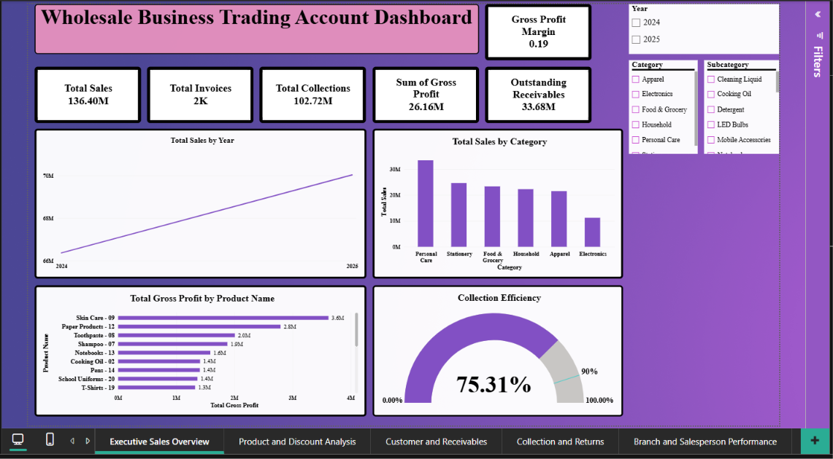
Page 2: Product and Discount Analysis
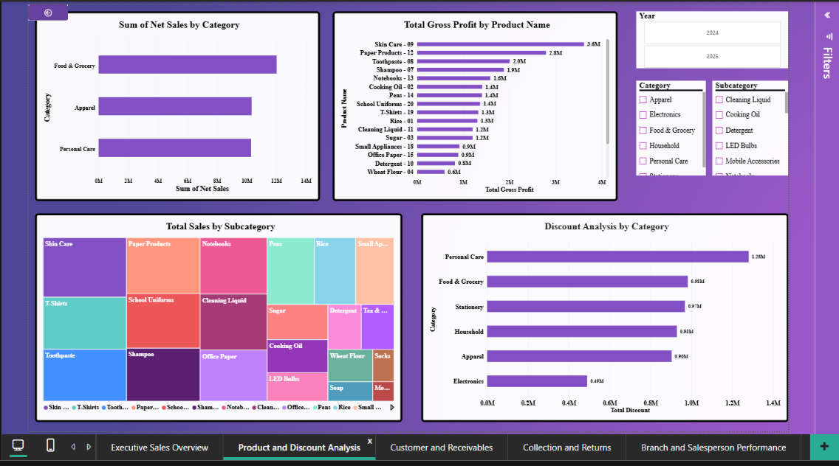

Page 3: Customer and Receivables
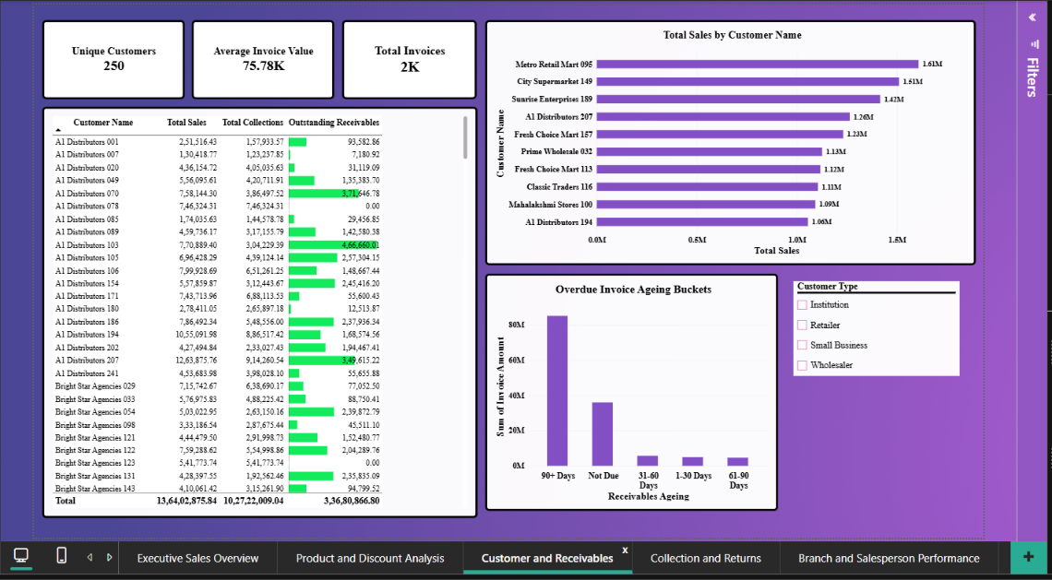
Page 4: Collection and Returns
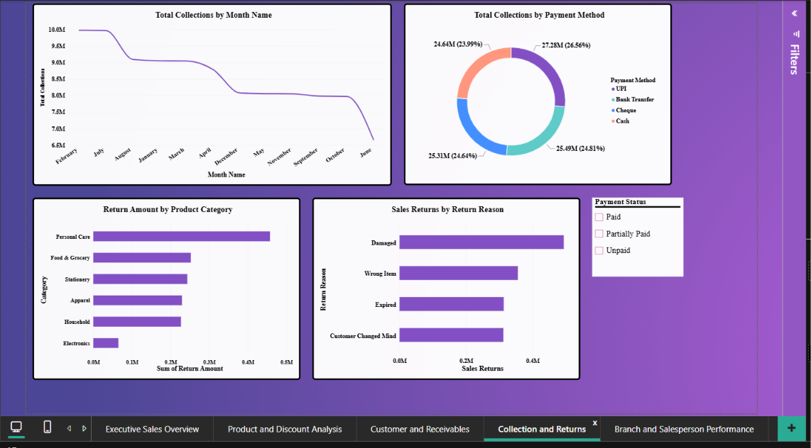

Page 5: Branch and Salesperson Performance
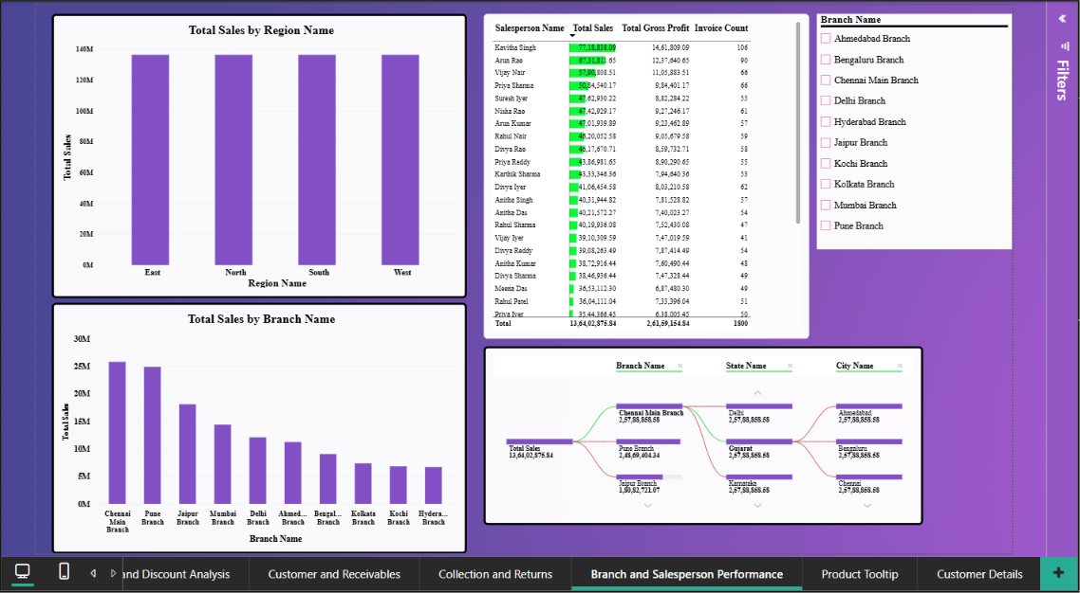
Page 6: Product Tooltip
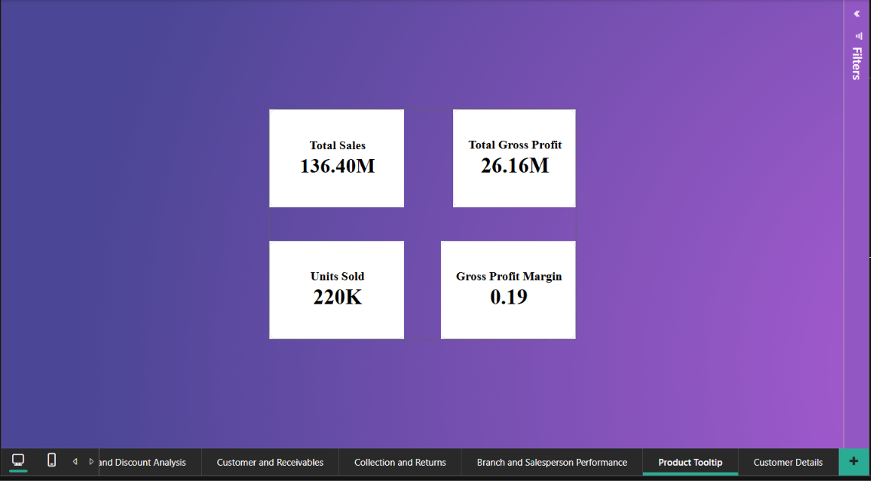

Page 7: Customer Details
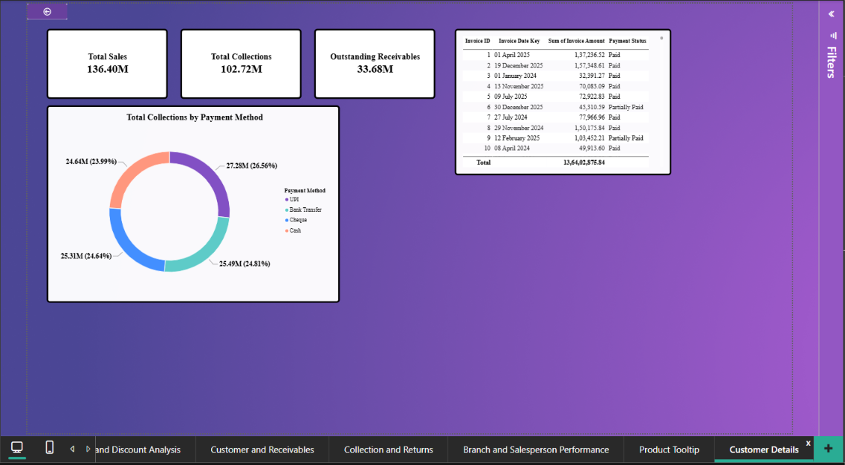
KPI Cards
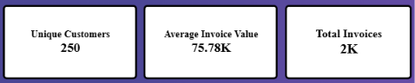
KPI cards were used to display key business metrics, including:
- Total Sales
- Total Gross Profit
- Gross Profit Margin
- Total Invoices
- Total Collections
- Outstanding Receivables
- Unique Customers
- Average Invoice Value

Line Chart
Line charts were used to analyze trends over time, such as Monthly Sales Trends and Monthly Collections.
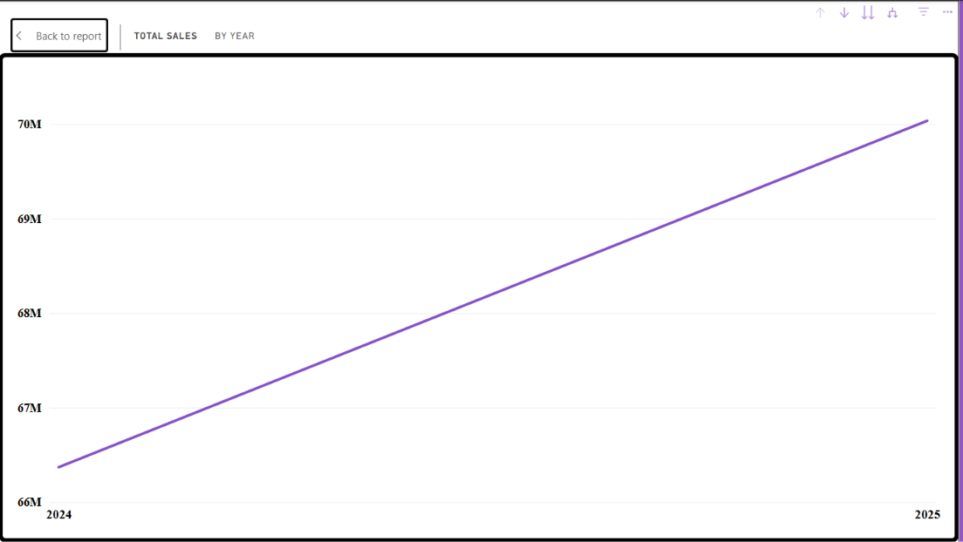
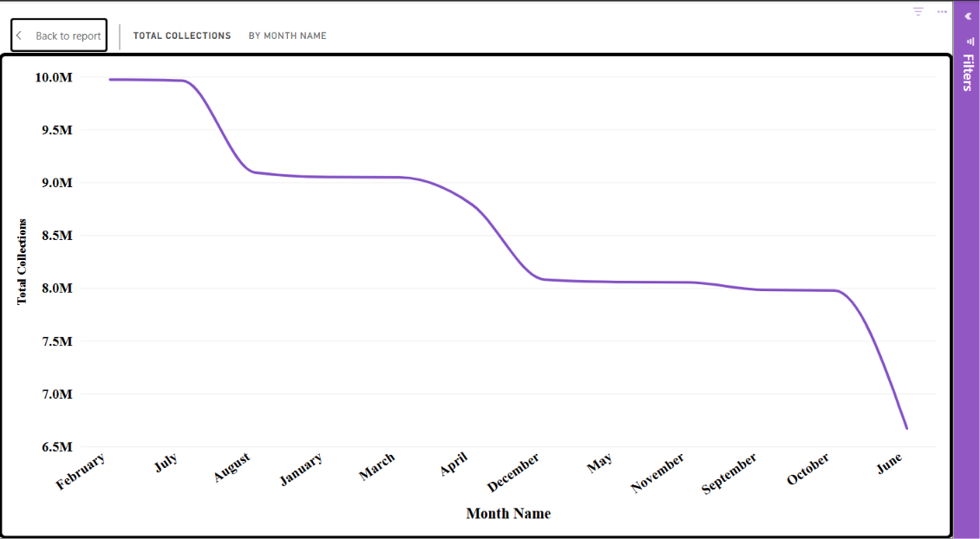
Clustered Column Charts
Clustered column charts were used to compare values across categories, including:
- Net Sales by Category
- Sales by Region
- Sales by Branch
- Overdue Invoice Ageing Buckets
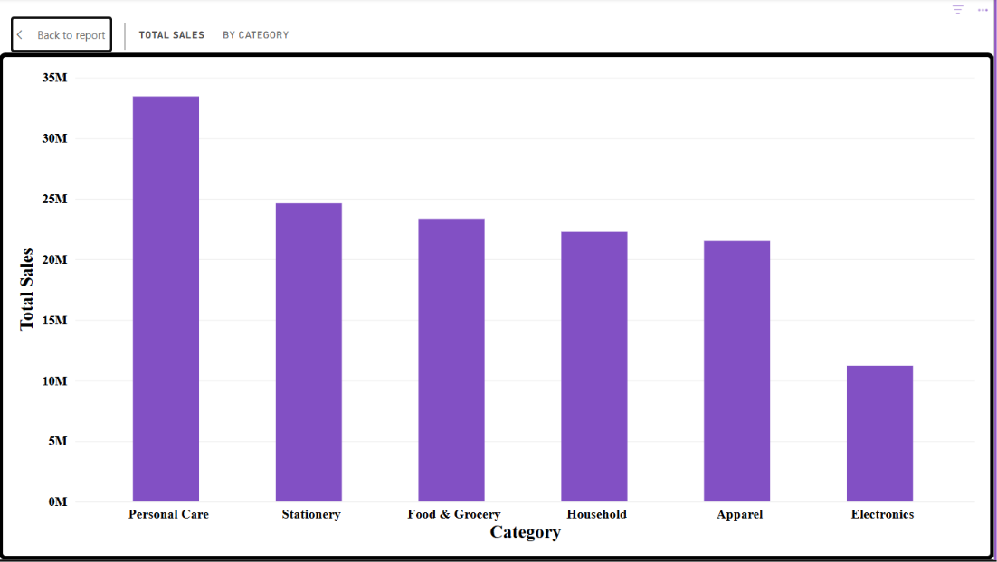
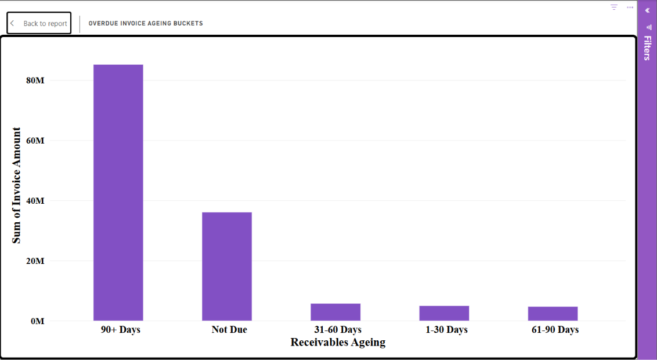
Clustered Bar Charts
Clustered bar charts were used to display rankings and comparisons, including:
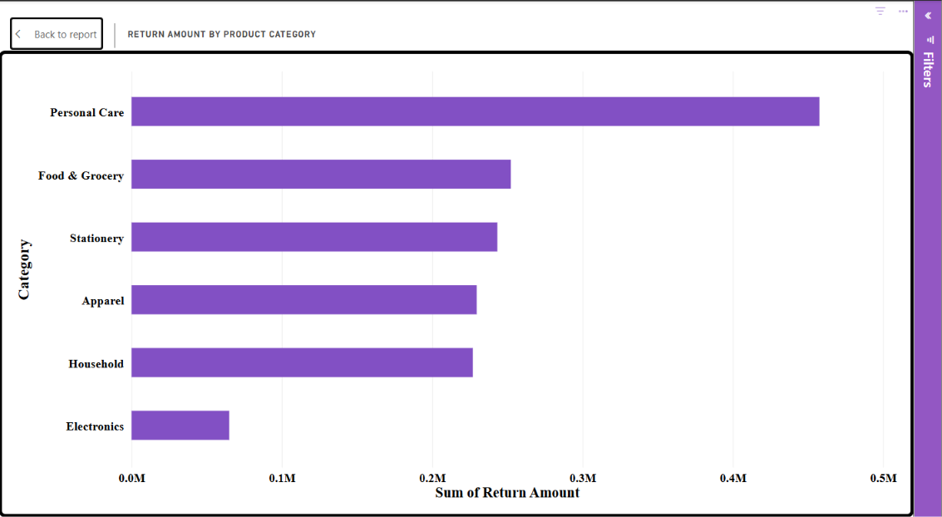
Gauge
It was used to measure Collection Efficiency by comparing the actual collection rate against a predefined target.
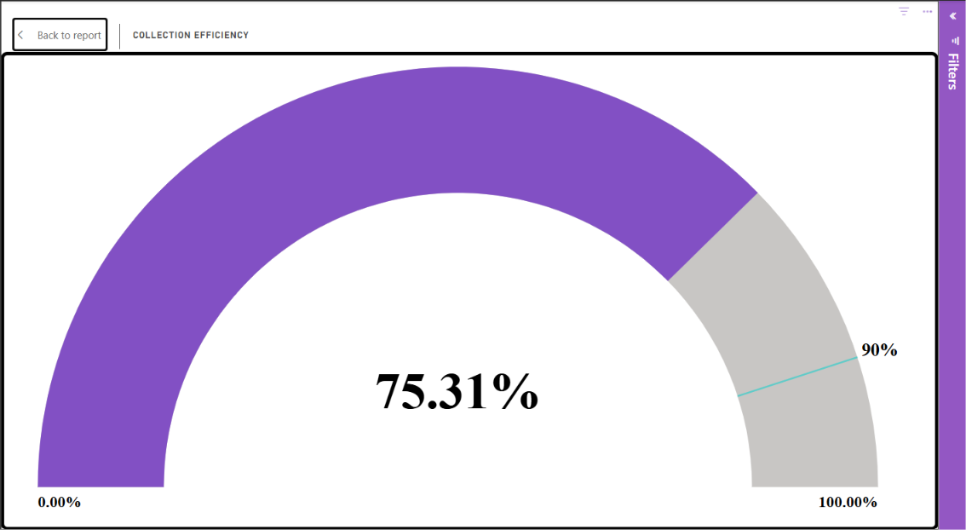
Stacked Column Charts
It was used to visualize the composition of data across categories and compare multiple components within a single category.
Stacked Bar Charts
It was used to compare grouped data and highlight category-wise contributions.

Treemap
A treemap was used to visualize Sales by Subcategory and identify the contribution of different product groups to total sales.
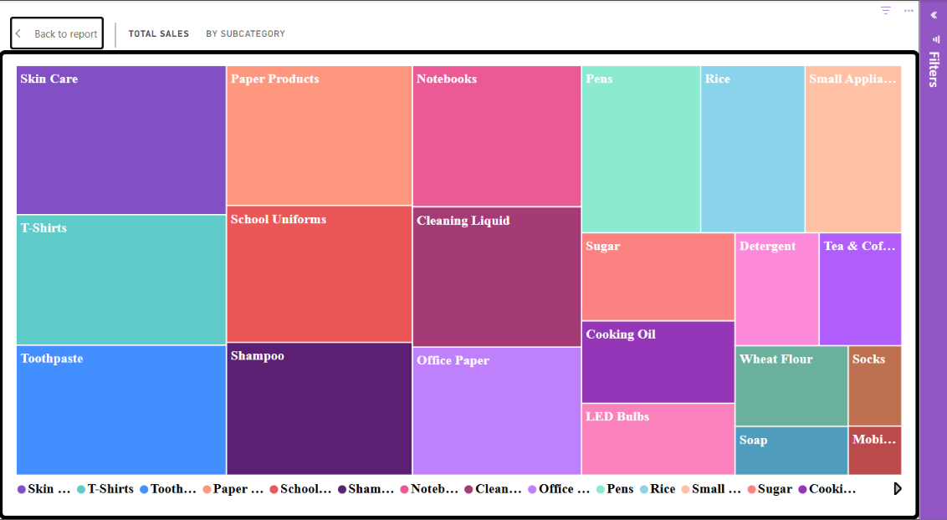
Doughnut Chart
Doughnut charts were used to analyze:
- Payment Method Distribution
- Return Analysis
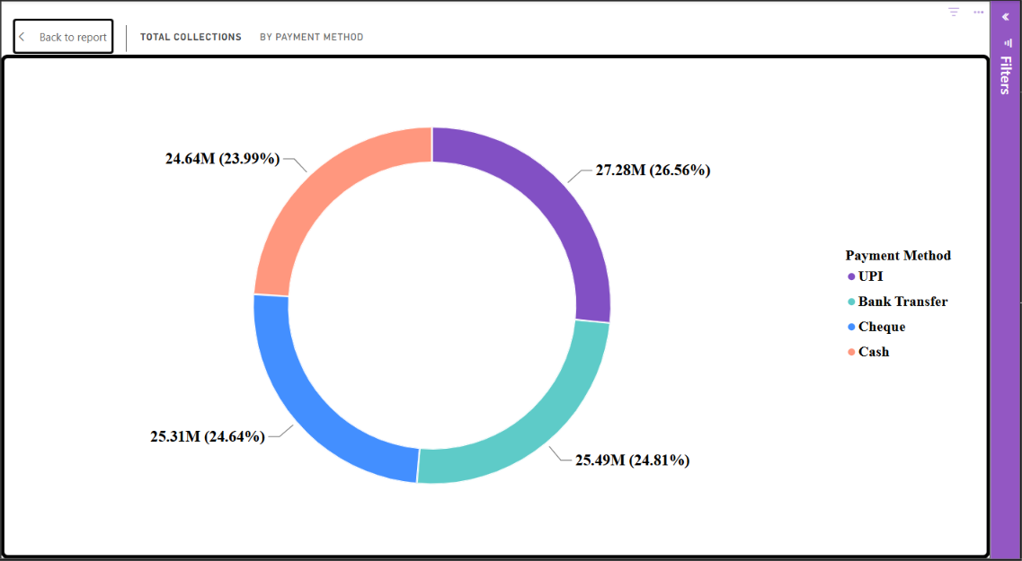
Tables
Tables were used to present detailed information, including:
- Customer Outstanding Balance
- Salesperson Ranking
- Customer Invoice History
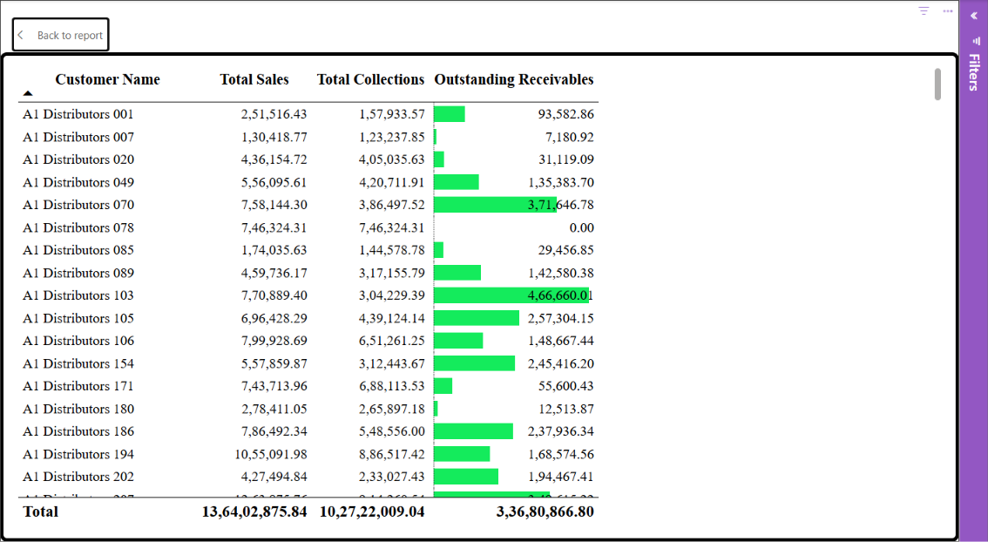
Decomposition Tree
It was used to analyse Total Sales across multiple dimensions such as Region, Branch, State, City and Salesperson.
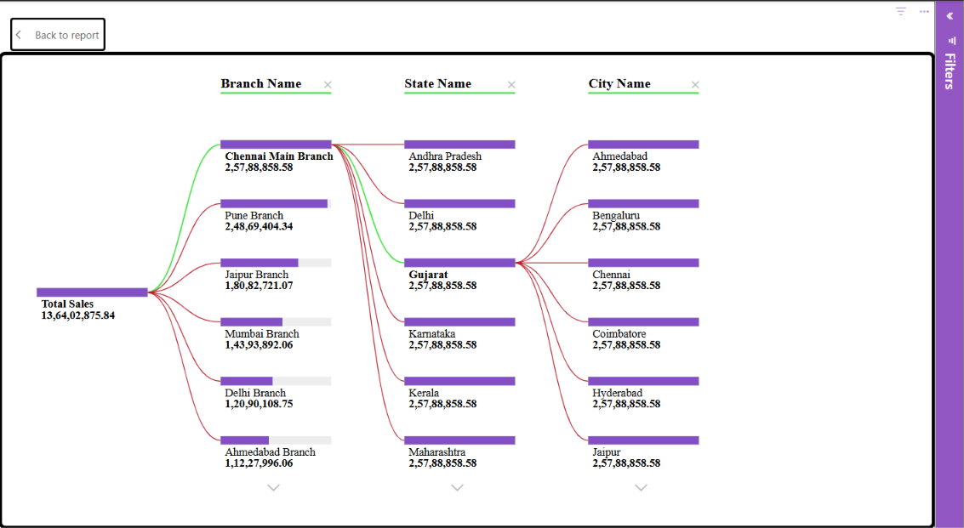
Top N Analysis
Top N Analysis is used to display only the highest-performing items based on a selected measure, making it easier to identify key contributors.
For this dashboard, a Top 10 Customers by Total Sales was implemented to identify the customers contributing most to sales.
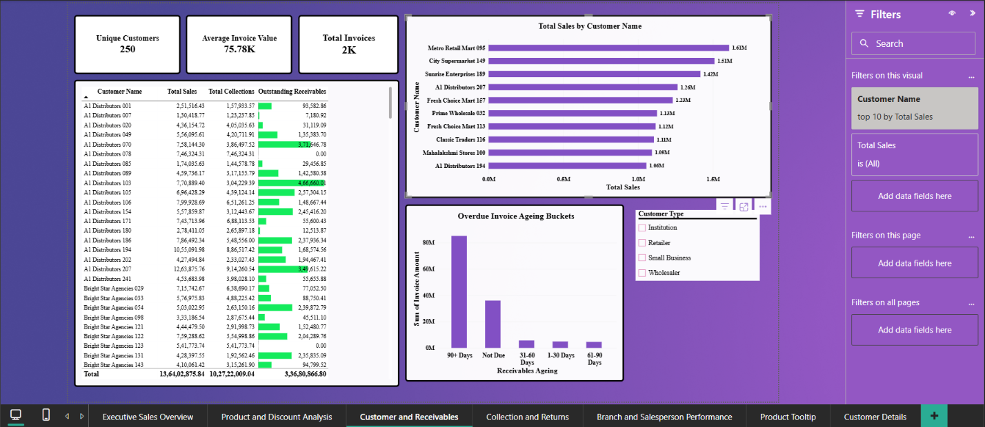
Slicers
Slicers were added to enable dynamic filtering based on:
- Year
- Region
- Branch
- Customer Type
- Product Category
- Payment Status
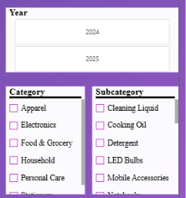
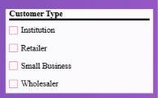
Drill-Down Hierarchies
Hierarchies were created to allow users to navigate across different levels of detail:
- Geography Hierarchy (Region → State → City → Branch)
- Product Hierarchy (Category → Subcategory → Product)
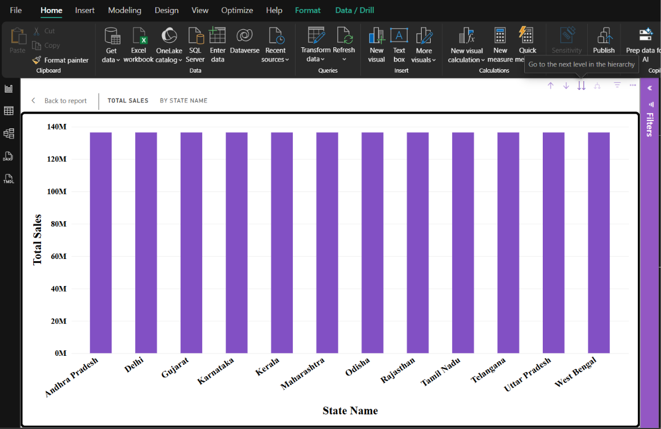
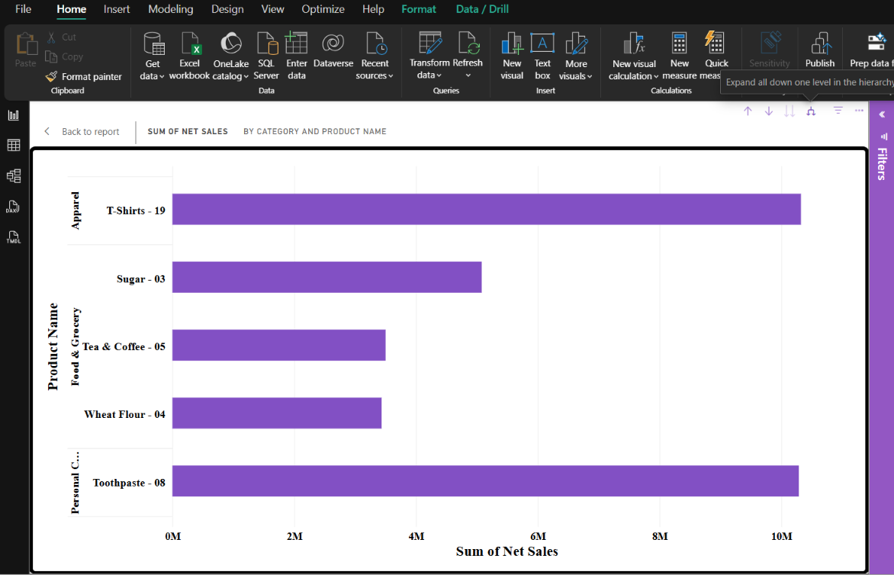
Report Page Tooltips
A custom tooltip page was developed to display:
- Total Sales
- Gross Profit
- Profit Margin
- Units Sold
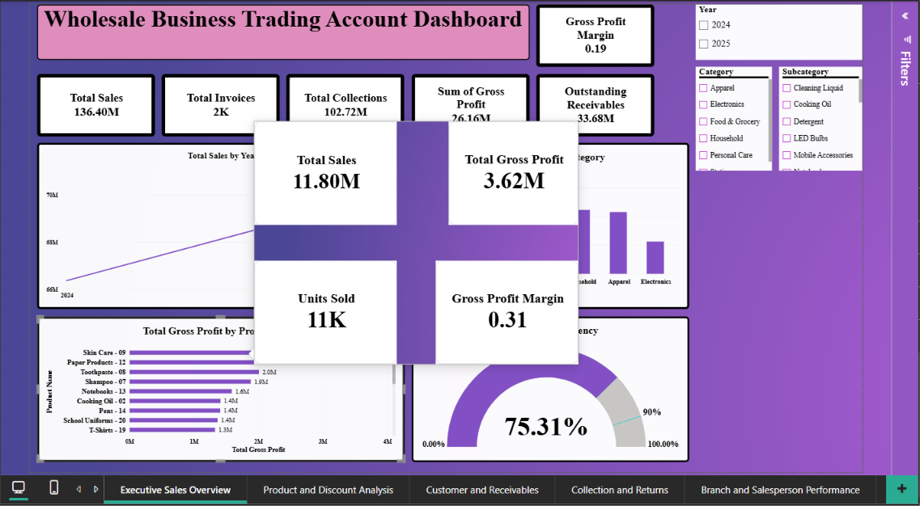
Drill-Through Page
A Customer Details drill-through page was created to provide:
- Customer Sales
- Collections
- Outstanding Receivables
- Invoice History
- Payment Method Analysis
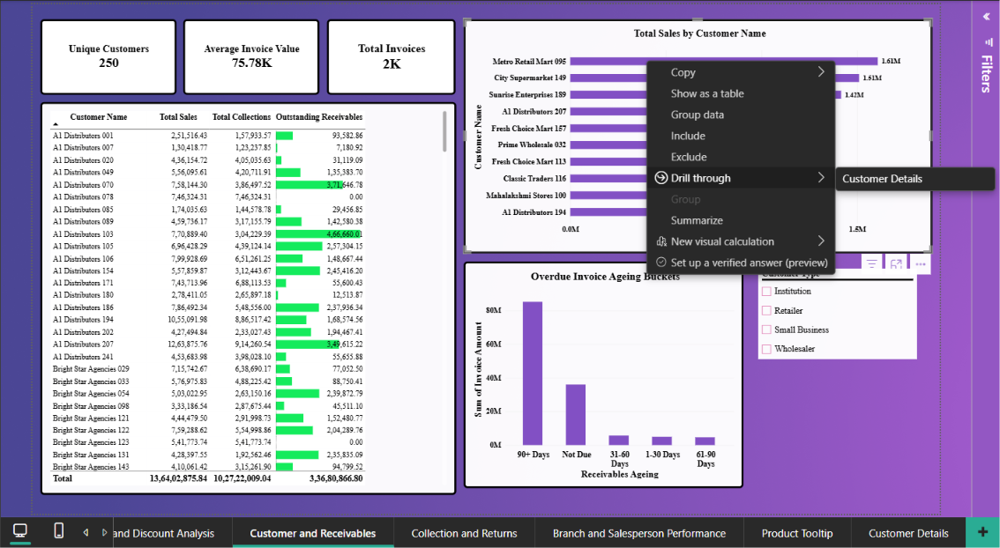
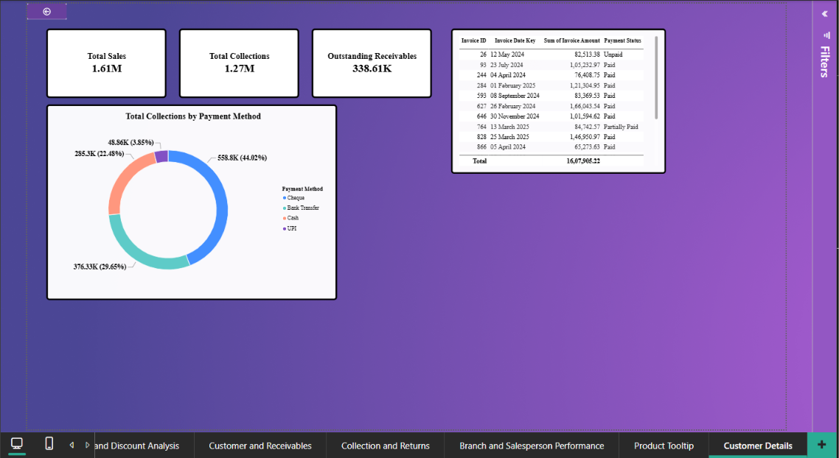
Conditional Formatting
Conditional formatting was applied to highlight important patterns and improve the readability of tables and performance rankings.
Filters and Interactions
Visual-level, page-level, and report-level filters were implemented along with edit interactions to enhance report interactivity and user experience.
Dashboard Visualisations – Three Insights for Each
1. Executive Sales Overview
KPI Cards – Total Sales, Gross Profit, Total Collections, Outstanding Receivables, Total Invoices and Gross Profit Margin
- The business generated total sales of approximately ₹13.64 crore, indicating a substantial volume of wholesale transactions.
- Gross profit amounted to approximately ₹2.62 crore, with a gross profit margin of around 19.18%.
- Total collections were approximately ₹10.27 crore, while the remaining invoice value of approximately ₹3.37 crore represents the balance before considering returns or credit adjustments.
Sales by Product Category – Column Chart
- Personal Care contributes the highest sales, approximately ₹3.34 crore.
- Stationery and Food & Grocery are also major contributors, generating approximately ₹2.46 crore and ₹2.33 crore respectively.
- Electronics records the lowest sales among the six product categories, at approximately ₹1.12 crore.
Discount Analysis by Category – Bar Chart
- Personal Care has the highest discount amount, approximately ₹12.81 lakh.
- Food & Grocery and Stationery follow, with discounts of approximately ₹9.83 lakh and ₹9.69 lakh respectively.
- Electronics has the lowest discount amount, approximately ₹4.90 lakh, which is consistent with its lower sales contribution.
Total Gross Profit by Product Name – Bar Chart
- Skin Care - 09 generates the highest gross profit, approximately ₹36.19 lakh.
- Paper Products - 12 ranks second, contributing approximately ₹27.93 lakh in gross profit.
- Toothpaste - 08 is another strong contributor, generating approximately ₹20.08 lakh in gross profit.
Collection Efficiency – Gauge
- The gauge provides a quick comparison between the actual collection rate and the defined collection target.
- The overall recorded collections amount to approximately ₹10.27 crore.
- The collection rate helps management assess whether payment collection performance is meeting the expected target.
2. Product and Discount Analysis
Sales by Product Category – Bar Chart
- Personal Care is the leading category in terms of net sales, followed by Stationery and Food & Grocery.
- Electronics contributes the lowest sales, suggesting that its contribution to overall business revenue is comparatively smaller.
- The difference between the highest and lowest categories shows that sales performance varies considerably across product categories.
Sales Contribution by Subcategory – Treemap
- Skin Care is the highest-performing subcategory, generating approximately ₹1.18 crore in net sales.
- T-Shirts and Toothpaste are also major contributors, with sales of approximately ₹1.03 crore each.
- The treemap helps identify the subcategories that contribute most to overall sales and those that may require additional marketing attention.
Discount Analysis by Category – Clustered Bar Chart
- Personal Care receives the highest total discount, indicating that a larger discount amount is associated with this category's sales.
- Food & Grocery and Stationery also account for substantial discount amounts.
- Electronics receives the lowest total discount among the categories, making it useful to compare discounting practices across product groups.
Gross Profit by Product – Bar Chart
- Skin Care - 09 is the most profitable individual product, generating approximately ₹36.19 lakh.
- Paper Products - 12 and Toothpaste - 08 are the next major contributors to product-level gross profit.
- These products could be prioritised when planning inventory and sales strategies because of their strong gross profit contribution.

3. Customer and Receivables
KPI Cards – Unique Customers and Average Invoice Value
- The dataset contains 250 unique customers, showing that the business serves a broad customer base.
- There are 1,800 invoices recorded in the dataset.
- The average invoice value helps understand the typical transaction size and supports comparisons between customer groups.
Sales by Customer – Clustered Bar Chart
- Metro Retail Mart 095 is the highest-contributing customer, with approximately ₹16.08 lakh in sales.
- City Supermarket 149 and Sunrise Enterprises 189 are the next major customers, generating approximately ₹15.10 lakh and ₹14.16 lakh respectively.
- The chart helps identify high-value customers and provides a basis for developing customer retention strategies.
Customer Sales, Collections and Outstanding Receivables – Table
- The table allows management to compare the sales generated by each customer with the payments received.
- Customers with high outstanding balances can be identified for follow-up and collection activities.
- Comparing sales and collections helps distinguish customers who generate high revenue from those who make timely payments.
Overdue Invoice Ageing Buckets – Column Chart
- The ageing analysis groups outstanding invoices according to how long they have remained overdue.
- It helps identify whether outstanding amounts are concentrated in recent overdue invoices or older unpaid invoices.
- The ageing categories can help management prioritise collection efforts, especially for invoices that have remained unpaid for longer periods.
4. Collection and Returns
Monthly Collections – Line Chart
- The highest monthly collection was recorded in March 2025, at approximately ₹53.76 lakh.
- December 2025 recorded the second-highest monthly collection, at approximately ₹52.68 lakh.
- The monthly fluctuations show that payment collections are not uniform throughout the year, making regular collection monitoring important.
Collections by Payment Method – Donut Chart
- UPI contributes the highest total collections, approximately ₹2.73 crore.
- Bank Transfer and Cheque are also widely used, contributing approximately ₹2.55 crore and ₹2.53 crore respectively.
- Cash has the lowest collection value among the four methods, at approximately ₹2.46 crore.
Sales Returns by Reason – Bar Chart
- Damaged products account for the highest return value, approximately ₹4.94 lakh.
- Wrong Item is the second-largest return category, with approximately ₹3.56 lakh.
- Expired products and customer changes of mind also contribute to returns, highlighting the importance of product quality and accurate order fulfilment.
Return Amount by Product Category – Bar Chart
- Personal Care has the highest return amount, approximately ₹4.58 lakh.
- Food & Grocery ranks second, with returns of approximately ₹2.52 lakh.
- Electronics has the lowest return amount, approximately ₹0.65 lakh, among the product categories.
5. Branch and Salesperson Performance
Sales by Region – Column Chart
- West is the highest-performing region, generating approximately ₹5.05 crore in invoice value.
- South follows closely, contributing approximately ₹4.84 crore.
- East has the lowest regional contribution, with approximately ₹73.81 lakh, indicating a considerable difference in sales performance.
Sales by Branch – Column Chart
- Chennai Main Branch records the highest invoice value, approximately ₹2.58 crore.
- Pune Branch is the second-highest performer, generating approximately ₹2.49 crore.
- Kolkata Branch records approximately ₹73.81 lakh, making it the lowest-performing branch in terms of invoice value.
Salesperson Performance – Table
- Kavitha Singh is the highest-performing salesperson, generating approximately ₹77.19 lakh in sales.
- Arun Rao and Vijay Nair are the next major contributors, with approximately ₹67.32 lakh and ₹57.91 lakh respectively.
- Comparing total sales, gross profit and invoice count helps management evaluate individual salesperson performance more effectively.
Sales Analysis by Branch, State and City – Decomposition Tree
- The decomposition tree allows total sales to be analysed through different geographical levels, including branch, state and city.
- It helps identify which branches and locations contribute more towards overall business sales.
- Management can use this analysis to identify geographical areas with lower sales contributions and explore opportunities for improvement.
6. Customer Details
Customer Sales, Collections and Outstanding Receivables – KPI Cards
- Total sales, collections and outstanding receivables provide a quick overview of the selected customer's financial activity.
- Comparing collections against sales helps determine how much of the customer's invoice value has been received.
- Outstanding receivables help identify customers who may require payment reminders or further credit monitoring.
Invoice Details – Table
- The table provides invoice-level information, including invoice ID, invoice date, invoice amount and payment status.
- It allows users to examine individual transactions instead of relying only on overall customer totals.
- Management can use the invoice details to identify unpaid or partially paid transactions for further follow-up.
Collections by Payment Method – Donut Chart
- The donut chart shows the distribution of customer collections across different payment methods.
- UPI, bank transfers, cheques and cash provide different payment channels for customers.
- It helps identify the preferred payment methods and understand how customers make their payments.
7. Product Tooltip
Product Performance Cards – Total Sales, Units Sold, Gross Profit Margin and Total Gross Profit
- The tooltip provides additional product-level information without requiring users to navigate away from the main dashboard.
- Units sold help identify the quantity of products purchased and indicate their sales volume.
- Gross profit and gross profit margin help users understand the profitability of individual products rather than evaluating them only by sales value.
Key Findings
Product categories: Personal Care has the highest net sales, followed by Stationery and Food & Grocery. Electronics has the lowest net sales among the listed categories.
Regional performance: West records the highest invoice value, followed by South, North and East.
Collections and receivables: recorded payments total ₹102,722,009.04. The simple invoice-value-less-payments balance is ₹33,680,866.80. Based on payments grouped by invoice, 1,095 invoices have recorded payments equal to or greater than their invoice amount, {partial:,} are partially paid, and {unpaid:,} have no recorded payment. This transaction-based view is more reliable than relying only on the invoice status label.
Returns: the dataset contains 199 return events, with a total recorded return amount of ₹1,474,952.78. The most frequent return reasons are Damaged and Wrong Item (52 events each), followed by Expired (49) and Customer Changed Mind (46).
Filters and Interactivity
The report pages include year filtering and category, subcategory, customer, payment, branch, region and salesperson breakdowns through their visuals and fields. Users can select a category, customer or location to cross-filter related visuals, and use detailed pages and the product tooltip to move from summary analysis to more specific records. Available slicers and interactions should be checked in Power BI Desktop during the final presentation.
Conclusion
This project demonstrates how Power BI can combine sales, invoice, payment and return data into a connected business analysis report. The dashboard moves beyond a simple sales total by including profitability, discounts, customer receivables, collections, returns and branch performance. The separate fact tables and dimension hierarchy make it possible to analyse the business from several perspectives while maintaining a structured data model.
Working on this project provides practical experience in importing and preparing data, creating relationships, developing DAX measures, choosing suitable visuals and building interactive report pages. It also highlights why careful treatment of payment and return transactions is important when analysing business accounts.
References
- Wholesale Trading & Business Accounts Analysis Dataset
- Microsoft Power BI Desktop.
- Microsoft Learn – Power BI documentation

